EXPERIMENT – 6

PAYROLL FORM :
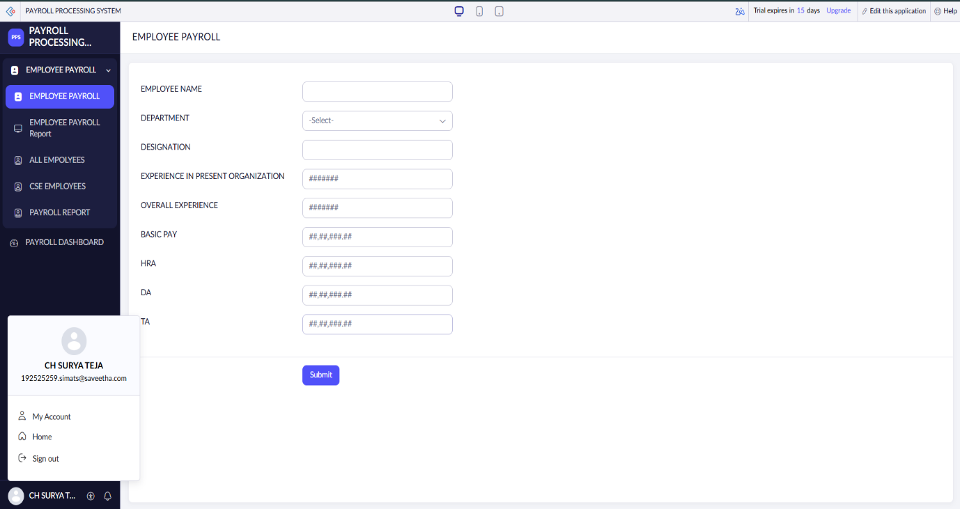
PAYROLL REPORT :
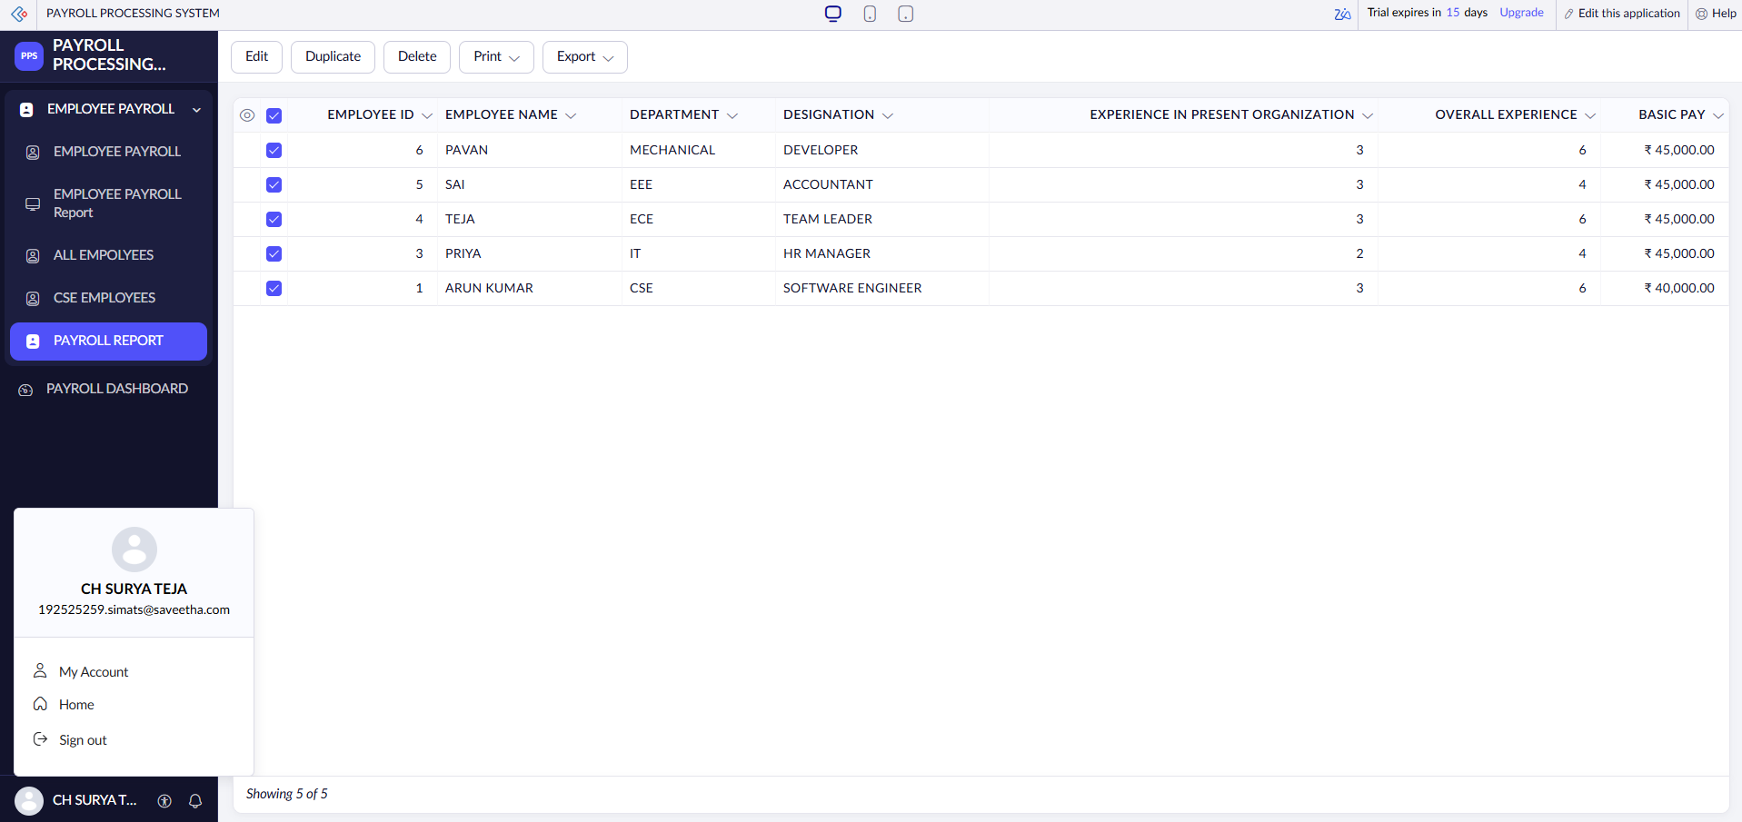

PAYROLL DASHBOARD :
